Retail Solution Centre Tour Script
Head Office – Visit 1

Presentation by T&K’s Commercial Director

Welcome to T&K’s European Head Office. We manage several business functions from this location:
- Commercial operations – design, buying, merchandising and inventory management
- Supply chain operations
- Store operations (although a majority of the management team is based in the field)
- Finance operations
- Marketing
- Property management
- Personnel/HR
- IT operations

During this first visit to the Head Office I would like to explain how we develop our product ranges and manage the implementation process with our stores. The agenda for the next 40 minutes is:

1 Customer Value Management
2 Category Management
3 Merchandise Planning
4 Range definition/Assortment planning
5 Sourcing and procurement
6 Range implementation into stores

1 Customer Value Management

To be completed

Background information:

We have a loyalty card with 2 million customer records
Sales data has been used to assess customer buying habits and profile
This has helped us refine our category offering – ensuring that we target their needs.

Content should cover:
- consumer purchasing patterns (basket analysis)
- how to exploit consumer loyalty
- how to use customer panels to assess range and category offerings.

Links to SAP - basket analysis (reporting) – probably phase 2
- article performance (sales velocity reporting) – phase 1

2 Category Management
The concept of category management was first discussed in T&K’s Board Room following the D&H acquisition.
The senior management team felt that there were significant areas for improvement within the commercial department. We had started to loose our way after two years of poor results and we really had to focus on getting the basics right.
The term Category Management means different things to every retailer. Yes there are various formal definitions (for example the Partner Group approach). But for us Category Management was a catalyst for educating our commercial teams in new and improved business methods and driving a change programme that included several new initiatives.
When we started (back in the summer of 1996) we were all very keen to understand what this concept of Category Management was and what it could mean to T&K’s. At that time I was the senior buyer for fashion. The CEO tasked me with performing an operational review of our commercial department functions (buying, merchandising and inventory management), which I undertook supported by business consultants from PwC and senior managers from D&H.

User Exit: Theory of Category Management
15 minute overview of common issues facing retailers, the concept of category management, and case studies

Possible content:
- Common Issues facing Retailers:
Process/functional silos – classic matrix organisation
No formal category review process or programme
Poor supplier relationships
- What is Category Management
- Case Studies:

Otherwise: The review highlighted some very common issues that are faced by retailers within their Buying and Merchandising Departments. We also learnt what other retails had achieved from category management initiatives. This led us to proposing a number of changes to our organisational structure and business processes.

- We often had no clear strategy on how to develop our product ranges – we were lacking direction and innovation
- Our commercial department was organised in functional silos and our buyers, inventory analysts and merchandisers all had different performance measures
- Our systems support was very poor
- collecting product performance information was extremely complicated – with our staff having to manually format reports based on data from up to 3 different system
- the legacy systems had some fundamental design issues that were preventing us from making many of the required systems improvements
- etc.

As a result of the review, I presented the board with a series of recommendations that, if agreed, would mean a change of operational approach, new business systems and significant effort from the business to drive the change forward.

Slide: List of Category Management Initiatives:
- The Senior Category Manager takes responsibility for the P&L of the category
- Restructuring of commercial teams – each category has dedicated buyers, merchandisers/planners, inventory analysts and marketing analysts (seconded from the marketing department)
- New Category Definition Process – formal definition of category role, objectives, financial and non-financial KPI’s
- Merchandise planning – formal process adopted to build consistent plans across all categories. These will also be reconciled with store operations plans. Within the fashion categories we also use the Merchandise Planning tool (Makoro from IBM) to develop the range assortment plans.
- Formal range definition/range review process – ensuring selected product will help meet/exceed categories objectives.
- Introduction of a new range implementation process – ensuring a formal process is adopted when implementing new lines in store (ensuring clear involvement and communication with both internal and external parties).
- Closer working relationships with our key suppliers (and a reduction in the overall supplier base) – with a key focus on collaborative planning
- New processes for managing promotional and seasonal lines.

The board approved the recommendations (after seeing the strength of the business case and how poorly we were performing against our competitors)
User Exit: Business Case Development – review business case material – Tony Maile to complete.
The recommendations have been implemented over the past two years. New business systems have been selected and implemented during this time (namely SAP, Makoro and Intactix) – these were necessary to allow all the new business processes to be supported.
T&K’s Category Structure

We now organise our business operations around the major category groups of:
- Home wares
- Grocery
- Fashion Apparel

Each category is managed by a senior commercial manager, who has responsibility for category profit & loss. The typical structure for our category teams is illustrated below – although we do have some variants.

Insert organisation slide – Commercial Team

Have we covered our market position with regards to each of these categories yet?
Do I need to have an overview of each category at this point? For example:

Category: Grocery
Category Definition:
Category Roles/Objectives:
Performance Measures:
Budgets:

Merchandise Hierarchy
As with most large retailers, T&K’s use a merchandise hierarchy to group like products within our category offerings. This allows us to plan business performance and organise our commercial teams. We have tried to keep our structures simple and our current hierarchy is comprised of 4 levels:

- Category, e.g. Grocery
- Department, e.g. Ambient non perishable
- Class, e.g. crisps
- Sub-class, e.g. multipack
- Article, e.g. 12 pack own label 40gr ready salted crisps.

Demonstrate the T&K merchandise hierarchy structure on SAP

One of the major advantages of moving to the new SAP system was the ability to report on sales and stock performances based on this single hierarchy and get one version of the truth.

User Exit – features of the SAP Hierarchy structure

- Flexible and easy to use
- Classifications, classes and characteristics:
- User defined merchandise classifications and classes are used to aid product selection (particularly useful for home shopping and kiosk usage) – examples
- User defined merchandise ‘characteristics’ are available to support additional levels of performance reporting. Examples include: brand, style, material, colour, size, product status (new line, promotional line, discontinued line). – lets look at a sample report…

Analysis of fabric, style, colour and size sales performance within fashion category
- Inheritance functionality – characteristics, classifications and classes can be defined at any level in the hierarchy – sub-levels will automatically inherit those structures and values
- Very easy to create new categories and product structures
- Ability to move re-classify sub-classes across the hierarchy – supported by tools to transfer product history

Article Structure
The lowest level in the merchandise hierarchy is the article level (SKU).
Each article placed on our shelves/catalogue pages has been through a rigorous selection and product introduction process. A key part of this process is the set up of the SAP article masterfile. This is the central data repository for product information for the business. It includes all the information required to purchase, ship, replenish and sell the product.
Before SAP we had 3 operational systems (finance, merchandise, warehouse management) and therefore three masterfiles to maintain. Two of the legacy systems had originally been best of breed packages (which were subsequently customised) with their own predefined masterfile definitions (obviously different). It was very difficult to effectively integrate the systems and masterfile data.
Now we have the one central repository

We have developed a work flow process based on our E-mail system (Lotus Notes) that ensures we collate the information necessary to introduce any new articles

User Exit: Workflow process to support definition and change of article masterfile information
User Exit: receiving product information from suppliers via EQoS application

The Article Masterfile supports the wide range of product characteristics we have within T&K’s – for example:
Style, colour, size & material for our fashion lines
Weight and dimension for grocery lines
Bill of materials (sets) for furniture within homewares category

We were able to add characteristics, e.g. brand, to facilitate additional levels of product performance analysis.

Demonstrate SAP Article Maintenance screen.
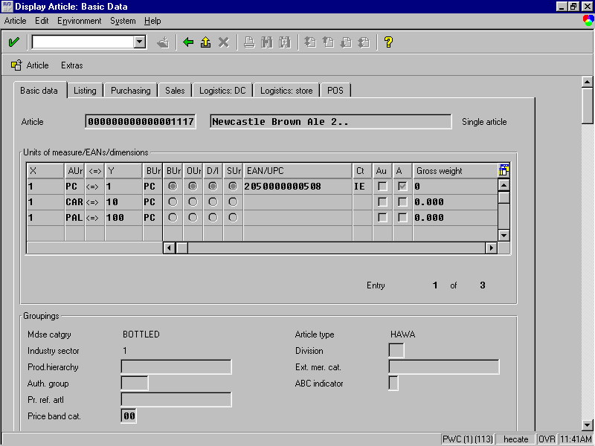

SAP system must have the following products entered into the Article Masterfile:

T&K’s Men’s Chinos trousers – via generic article

6 colours – black, sand, gunmetal, sage, navy, stone

inside leg – short, medium and long

waist (inches) – 28, 30, 32, 34, 36

Price £29.99

T&K Multipack Crisps and single packs

Flavours: salt & vinegar, ready salted, Cheese & Onion, Mixed Packs

Weight: 25g per pack

Multipacks – 6, 12

T&K Candles

A branded Grocery item – e.g. Heinz Tomato Ketchup

Also include electronic media such as audio track that could be down-loaded via the internet. What about services such as gift wrap, travel insurance, etc?

Jeff Toig to confirm list of all articles required for demonstration purposes

Article Masterfile Demonstration – illustrating key features:
- Basic product Data – including T&K specific ‘characteristics’
- Listing (covered in greater detail later)
- Purchasing information
- Sales information (pricing)
- DC replenishment data
- Store replenishment data
- EPoS information

Key functions to discuss:
- Basic Data – colour, size, weight – this information can be passed to the Intactix to support the development of plannograms.
- Can support multiple EAN’s and pack size definitions
- Flexible Article pricing – cost price, other cost components, retail selling price (by region/store if appropriate)
- Support for multiple vendors (supplier specific quotas can be defined)
- Supplier details
- Generic article functionality – expand
- Other features ???

With the latest release of the SAP Retail software (version 4.5) the developers have introduced some comprehensive mass maintenance tools. These allow the user to ….Ranvir Puri to confirm.

Question – has anybody covered store hierarchy structures before this point? (Jeff?)

3 Merchandise Planning

As part of the Category Management initiative we have introduced a new business planning process.
Our buying teams are now required to demonstrate (via the merchandise plan) that the category offer will be capable of delivering T&K’s performance objectives.
The category controllers were keen supporters of this initiative as it places a degree of rigour on the planning process – and everybody works from the same base line.
In the following presentation I will summarise the key process steps of T&K’s business planning cycle and illustrate how we develop budgets that are owned across the business.

Slide 1 - Before Category Management:
- No formal planning process
different approaches adopted by Finance Dept, Buyers (also differences across categories), store operations, etc. Impossible to reconcile and no formal mechanism for maintaining changes.
- No systems support
the finance department used a range of spreadsheets that had been developed over a number of years. Some, but not all, of the buying teams developed plans based on spreadsheets – but each team had their own preferred approach.
- Across the commercial floor, business performance was only reported against last year – not against budgets

Slide 2 – Business Requirements:

- Business performance planning (financial, merchandise and store) must be co-ordinated across a number of departments. This requires a clear documented process and timetable.
- Given the volumes of data required, and the complex data manipulation that must be performed during the plan development process, it was decided that a dedicated merchandise planning toolset should be adopted (to aid rapid implementation).
- MakoroMP from IBM was selected as it provided a clear fit to our functional, technical and commercial selection criteria. IBM were also able to provide QuickStart – a pre-configured base system which allowed us to start merchandise planning within X weeks of installation.
Slide 3 – Business Planning Overview

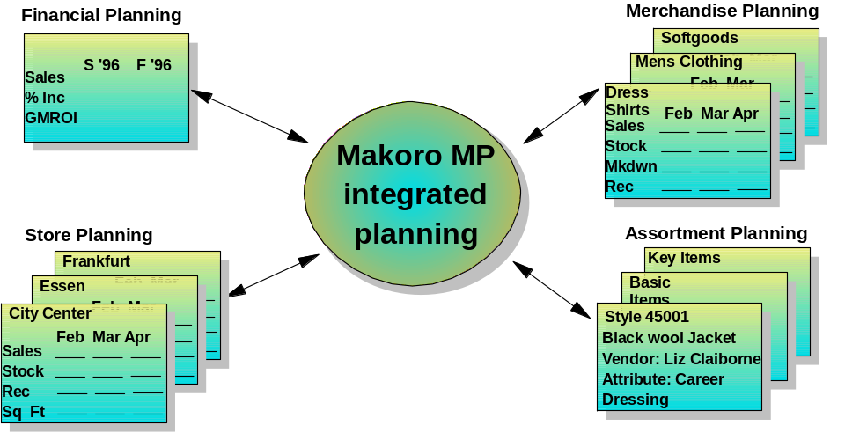

Slide 4 – Planning Cycle
We have refined our planning process after the first year. We now have a clearly documented schedule for developing plans and performing the business reviews (see Diagram – to be completed)

Slide 5 – Budget Components

- T&K’s 5 year business plan - drives overall board objectives for the year – defined in introduction
- Strategic merchandise plan - example required based on Makoro QuickStart model – this covers category level performance objectives
- Merchandise plans – detailed performance planning down at the sub-class level – these must reconcile with the strategic merchandise plan
- Store Operations Plan – allows store performance to be planned at category level (sales, footage and sales density). Makoro can also be used to determine store grades by category.

Each merchandise plan provides views of category performance by week down to the sub-class level on:
- Sales
- Markdowns (authorised discounts)
- Promotional discounts
- Target margins for category
- Target shrinkage
- Closing stock figures
- Stock intake requirements

Demonstration – Makoro Business Planning Overview (assistance required from Richard Cooper to prepare demo)

The Eight Module Process
The eight modules are:
Strategic Financial Plan
Product Plan
Product Extended
Store Plan
Grade Plan
Store/Product Calculation
Assortment Plan
Key Line Plan
The diagram below shows each of the modules and the relationship between them. The underlying business principles upon which each module has been built are also described below.

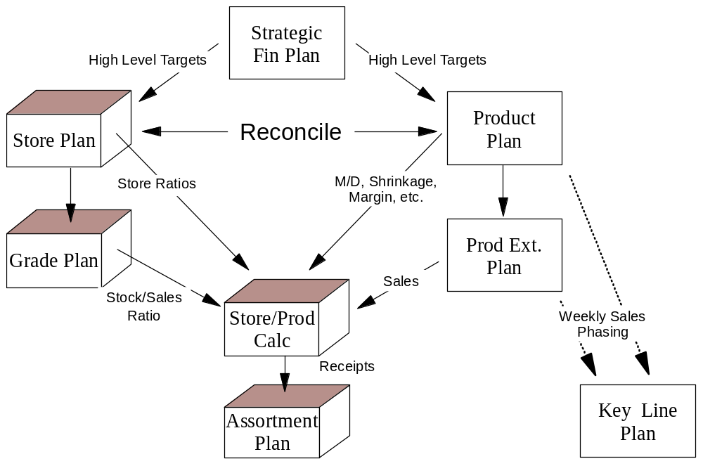

Note: the QuickStart system and process template still provides the basis for the structure currently being used within T&K’s, although it has been modified to suit some of the particular requirements of our business. For example, we wanted to plan our fashion categories in terms of new, promotional, continuity and discontinued lines.

Makoro and SAP have established a strategic relationship to work together – providing a seamless interface between the merchandise planning system and the SAP Retail system. The key functional interfaces will be:
Interfacing agreed budgets from Makoro to SAP
Interfacing actual performance data from SAP to Makoro to support the re-forecasting process
Product volume information:
For fashion – recommended product quantities by style
Supply chain – high level volume estimates (based on average price point by sub-class)
Suggested allocations – based on store grade definitions
OTB and PO Commitment data (depending on where OTB controls are maintained – at the moment I am assuming that we will utilise SAP’s OTB control framework)

4 Range Development/Assortment Planning

At T&K’s we have refined our category offerings to reflect the demands of our customers. We also have to ensure we meet our profit target, which is why it is so important to involve the category teams in the budget setting process.
The range development process does vary depending on the nature of each category and it’s positioning.

For Fashion:
Our aim is to provide an up-market own label ‘lifestyle’ brand for men, women and children. We must link our offerings with the latest colours, fabrics and styles (recognising that our main target audience is in the 35-50 year age bracket – so only a limited percentage of our offering would be considered ‘high fashion’ by our competitors). We aim to achieve an overall margin for the Fashion Category of 60% so we have to ensure we select and design the right types of products and minimise markdown whenever possible.
Like most fashion retailers we have to offer a wide variety of products throughout a season (Autumn/Winter and Spring/Summer). We want to offer our customers variety and they expect to see new lines coming into our stores on a regular basis.
As a result, managing an ‘own-brand’ fashion category has some specific characteristics that need to be clearly understood when developing the range and assortments for our stores.

- We are heavily involved in the design and manufacture of our product lines – we need to have very close links with our supplier base and visibility of our commitment to stock.
- Over half of our lines are one-off designs that reflect (hopefully) a particular season’s trend with regards to colour, fabric and style – there will be a limited window of opportunity in which to sell these lines.
- As a result, stock planning is critical. If we under plan stock requirements we will miss out on good revenues, if we have too much stock (and/or get the fashion mix wrong) we may have to heavily mark down the retail price to ensure the stock is sold.

The typical range development process for one of our fashion categories, men’s trousers, for the spring/summer season 200X is summarised below:

Fashion Range Development Process

Timetable:

Process starts 12 Months before Season

- Senior buyers and designers present expected fashion trends (based on trade shows, etc) to the Fashion Category Teams
- Category Teams prepare response (2 weeks later) – they will prepare information at the sub-group level on:
- Key fashion styles
- Colour palette
- Target sales, margin, mark-down, promotion and OTB figures
- Space requirements
- Makoro demonstration required to illustrate this process – input required from Richard Cooper
- Review then held with Fashion Category Controller – with the aim of agreeing style/colour/price/space mix.
- Range Design and Build
- Plans translated into product designs and specifications
- Activity co-ordinated with key suppliers
- Products must also be co-ordinated across the category wrt style and colour, e.g. t-shirts, shorts, training shoes, etc
- Merchandiser builds plan of required style, colour and size by store grade, including selling timeframe
- Proposed range is merchandised (with POS material) – suppliers provide samples of designs. The Fashion Category Controller, CEO and Store Operations Director review this, together with the Merchandise Plan.
- Once the range is agreed commercial arrangements are agreed with the suppliers. This will include forecast quantities, phasing of delivery (commitment agreements), confirm design specifications, purchase price, rebate structures, one-off payments to support promotions, etc.

Design specification for product will be held within the SAP Product Catalogue.

Benefits of this approach:
Standards, auditability, and reduced workload due to level of systems support.
Makoro demonstration and slides required to illustrate:
- Calculation of style/colour options required for each sub-class
- Demo based on T&K’s Men’s Tailored Trousers – Makoro demostrates that range for large stores needs to contain 3 styles and 6 colour options and X units of stock to meet targets.
- Links between SAP and Makoro – what is available now? What will be delivered in future releases.

Questions:
- How is product design information shared/developed with suppliers – investigate support tools such as EqoS, Fashion Yield
- Check T&K store grades have been defined within Store overview section

For Grocery

T&K’s proposition is to offer a mixture of branded grocery goods as well as a selection of ‘good quality’ own-brand products. The focus for own brand in recent years has moved towards the ready meals and the meal solution centre, e.g. Children’s party food.
The range development process is very different between the fashion and grocery categories.
T&K’s have limited space to dedicate to grocery when compared to the supermarket grocers such as Tesco and Sainsbury. Therefore we have to provide a clear proposition to our customers – that differentiates our offering.
Our Grocery Category objective is to provide an imaginative, easy to shop grocery environment that provides ideas and solutions to our customers as well as providing excellent value for money

Range development process
Each sub-class within the grocery category will undergo a formal range review on a yearly basis. A schedule for performing range reviews is published by the category controller each year.

Inputs:
Sub-class performance: last year, budget, actual performance to date
sales, margin, space productivity (yield)
best/worst sellers
best/worst suppliers

Market Trends: market growth potential
T&K market share

New Product Evaluation: working with suppliers

Outputs
Proposals for range changes: new products
identify products for discontinuation
Proposals for new ranges:

Case Study: to be confirmed

For Home Wares

Our range offering with the Home wares category is a mixture of both fashion and commodity product lines.

Examples:

Fashion based lines:

Commodity lines:

Process for range development – to be completed

Talk to Ros Roswarne Jenkins about relevant examples

Entertainment Category – are we still doing this?
5 Sourcing and Procurement

Introduction
In 1996 T&K’s had over 600 suppliers providing merchandise to the UK business. The business was approximately 60% domestic, 40% imports. As part of the Category Management initiative we initiated a programme of reviewing supplier performance – our objective was to develop closer relationships with a smaller supplier base.

Sourcing
Product and suppliers are selected based on their ability to provide T&K’s with appropriate product profitability and service levels.
As part of the range review process, suppliers will be evaluated against a number of criteria:
- Past performance with T&K’s
- Proposed deal meet T&K’s commercial objectives – margin contribution, rebates, service levels
- Supplier capacity – what percentage of business is from T&K’s

SAP allows us to review supplier performance. Information on product and supplier profitability and service level is captured on a daily basis and is available via the reporting system.
User exit: Supplier performance review case study
Total product sales, margins achieved
Purchase history/rebates
Service levels

SAP allows us to model retail selling price based on cost price, target margins and price point strategy.
User exit: price point strategy definition & cost modelling

Procurement
Once agreed, the components of the deal are recorded on SAP.
Demonstration:
Standard Contract on SAP
- Details articles, price (including sliding scales), other cost components (e.g. delivery costs), payment terms, etc
- Purchase orders (manual or automated) will reference the contract details as part of the PO creation process
- Standard contract could be set up to support a group buying function – to support international retailers
- Demonstrate contract for Men’s Tailored Trousers

Defining rebates (subsequent settlement)
- Based on quantity or value within a certain timeframe
- On-line rebate monitoring
- Two methods for obtaining rebate payment – claim credit against next supplier invoice or raise debit note
- Demonstrate rebate arrangement with crisp manufacturer
- Show set up of subsequent settlement
- Run rebate assessment enquiry

6 Range Implementation into Stores

Is this whole section a user exit?

Implementing any new product into stores is treated as a project. There are certain steps that must be followed to ensure a smooth implementation process.

The implementation process covers:

- New range implementation, e.g. the launch of the new Autumn/Winter range
- Wave merchandising, e.g. introducing new lines during the season
- Introduction of seasonal lines
- Introduction of promotional lines
- Replacement of discrete lines because of poor performance or supplier issues

The process starts once the structure of the range has been completed and signed-off.

- ensure article masterfile is correctly populated – especially price information and supplier contract details
- ensure plannogram is developed to reflect proposed layout and that initial order quantities are planned – what automated interfaces exist to support this link between SAP and Intactix – need to capture shelf capacity and minimum credible display quantities – what is current status of Intactix installation
- describe line listing approach – specifying the link between range assortment and store grade - Ranvir to confirm approach
- define on-going replenishment characteristics by article, e.g. specify as ‘sale and send’ replenishment and work with suppliers to develop a joint forecast for stock requirements
- Set dates for range/product introduction
- Agree exit plan for any existing stock that will be replaced by new lines (options include markdown, supplier uplift and wastage (sold to ‘jobbers’)
- Send communications pack to store – includes planogram, range listing information (get example of SAP Output), labels (to be printed in store – can we demonstrate this?) and merchandising instructions
- Ensure stock is delivered into store JIT – we discuss initial purchase and allocation of stock to stores within supply chain area
- Arrange for external merchandisers to attend stores to help with new layouts, etc.

Head office provides a hot-line for store staff to support queries regarding new merchandise layouts.

Head Office – Visit 2

Presentation by the Commercial Director

Welcome back to T&K’s head office. I hope you now have a clearer understanding of how we manage the core supply chain processes within our business based on T&K’s category management approach.

I would like to tell you more about the changes we have introduced – but first I would like to re-iterate some of the key features we were looking for from our new business systems:
- significance of automation - information should be available at the business user’s fingertips - via easy to use ‘drill-down’ type pre-formatted reporting systems. We should be able to rely on our computer systems to collect and present our business information for action by business users. We need to move away from using valuable business resource in the ‘formatting’ of business information (spreadsheets, etc.) to more proactive, value adding activities.
- single input processing - robust system interfaces should ensure that we do not have to enter business information more than once.
- single version of the truth - all reports are derived from a single data source to provide absolute consistency of business information across the business
- integrated KPI’s used across the business - based on agreed standard definitions
- we need to generate a culture of discipline around maintaining data integrity and accuracy (each element of data should have an owner - generally, this will be the user that initially inputs the data).

I guess these are fairly typical aspirations for any business – however, these principles represented a significant step forward from where we were with our legacy systems.
The real benefits from implementing ERP solutions are seen through the seamless integration of business functions.
Let us explain what benefits have been achieved within our Finance Department through the implementation of SAP Retail.

Link to Finance Presentation

Firstly, I will describe the impact the SAP has made in our Finance Department

I will then describe how SAP supports the on-going management of our ranges.
- Monitoring range performance
- Price management
- Managing promotional lines
- Managing seasonal lines

FINANCE TOUR

In-Season Category Management
Welcome back to the Commercial Department. Rather than listen to me tell you about how we manage our categories during the year/season, why don’t you come and join me at one of our category review sessions. I am meeting the Grocery Category Managers to discuss current business performance. Hopefully, you will see how easy it is for us to get access to the performance information we need.
Demonstration:
Props:

I would like to introduce Charlie, our Grocery Category Manager. Charlie has been with us for 5 years and has been closely involved with the Category Management development programme. Charlie, maybe we could start by telling our visitors what it was like preparing for this review meeting before we had SAP Retail.

Charlie: well, like most retailers I have worked for, there would always be frantic activity every Monday and Tuesday trying to prepare the necessary performance reports. Because we had so many systems we often had to pull data from many places and manually format reports. A lot of our junior staff spent much of their time doing this and we had a problem with high staff turnover. Once we actually had the reports there were always concerns about the accuracy of the information.
It was also very difficult to analyse what the key drivers were within each category – I was a keen advocate of the drill down reporting function that we now have within the SAP Retail system.
Commercial Director: Yes, I remember how frustrating it was to get answers. Maybe you can give me the highlights from last week’s results and our visitors can get a feel for the type of support we now get from our business system.
Charlie: No problem.
We normally perform this review using the SAP Retail Information System. We have a standard set of report enquires that link in with our category KPI’s and we tend to review the figures on-line. The drill down facility allows us to pinpoint particular areas of success or concern and we can discuss short, medium and long term action plans.
My Commercial Director has access to all these reports on his PC. Being a complete workaholic, he often has spent more time studying the results before our meetings than I have!

Just before I show you our reports let me just explain how these were set up. The Retail Information System is a reporting toolkit provided with the SAP system. There are a number of standard data structures already set up in the system. However, you have the flexibility to develop additional reports and enquires.
At T&K’s we were keen to eliminate the massive amount of paper we received every week – so we try to review results on-line if possible – some of our staff still prefer to kill forests (normally the older members or technophobes within our group)

Grocery Category Performance Management
Within the grocery area our main focus is on sales, margin and return on space. We need to ensure that our sales are (hopefully) exceeding budget and that the promotions we have underway are having the desired effect.
Lets show you how T&K’s grocery offering is doing:

Enter reporting system – Grocery Sales Reporting
Need to demonstrate:
Grocery sales sales TW, budget TW, var, sales YTD, budget ytd, var
Total category
Div 1
Div 2
…
Div n

We can see a problem with dry goods – we appear to be well below budget. I can use the drill down functionality to investigate what might be causing this issue.
I plan and monitor category performance across our store portfolio and via this system I can see that the main reason my results are poor is because our Northern Region is performing very badly – what could be causing this? In the old days I would try and contact our Northern Region Operations Manager – he is always on the road and getting his input could take days.
In this particular case, I can see via my link to the stock reporting enquiry that we major issues on stock levels in store this week. I know my inventory analyst will be aware of this as the SAP systems exception reporting facilities will have informed him that stock levels are very low. I will make sure I see him straight after this meeting. (link this with next Supply Chain section)
We can also see that xxxx is performing very well against budget. We only have this class of product in our larger stores – we need to assess if it is worth moving the range into our other store grades.
I also like to look at the sales velocity report to understand which are our best and worse performing items per product class. I can rank performers by both sales revenues and margin contribution.
Of our 10,000 product lines the top 20% contribute 70% of our sales. The bottom 20% contribute only 5% - this is why it is so important that we control our ranges carefully.
Since the implementation of SAP we have introduced new price point analysis and maintenance processes. SAP gives us the flexibility to have regional, area and even store specific pricing. We have used this to good effect and now do price point sensitivity trials, i.e. we compare article sales velocity before and after a price change in a trial store. We recently performed a price trial on Australian wines, which resulted in us increasing the retail selling price of three articles by 50 pence. We calculated that this alone could increase profits on this sector of wines by 100K per year (assumes we sell wines in 100 of our stores, 24 bottles of each line per week).
Within Grocery we aim is to optimise return on space. Our SAP and Intactix systems (recently implemented) will give us a very clear picture on sales and margin returns per sq ft of each product range.
User exit: Intactix/SAP space performance monitoring. Need to nominate an owner for the Intactix area within the project team – what can be delivered?
There are a number of reports that our category team use on a daily, weekly and monthly basis to monitor category performance. The most commonly used are:
Daily
- Total EPoS sales
- Mark-down analysis (fashion and home wares categories)
- Out of stocks – store and DC
- Late delivery reports
- Created purchase orders – requiring authorisation

Weekly
- Sales, margin, stock availability/level compared to plan– with particular focus on fashion/promotional lines
- Open to Buy analysis (fashion category)
- Mark-down analysis (fashion and home wares)
- Sales velocity reporting - best and worse selling lines

Monthly
- Gross Profit analysis
- Supplier performance – including rebate contribution – planned against actual
- Space performance
- Shrinkage
- Market share information – from external source
- Customer information

T&K’s are able to calculate a true gross margin and gross profit figure on a regular basis. This is because they are able to allocate cost elements such as distribution, shrinkage and financing to the line level on a monthly basis for Gross Margin. Other costs/payments can also be applied to calculate the gross profit contribution of the category.
Budgets are reviewed on a quarterly basis. We do the re-forecasting activity within the Makoro package and then download the results to the Retail Information System.

Category Controller: thank you Charlie – you better find out what is going on up in Scotland.

Managing Promotional Lines

Charlie mentioned how important our top performing lines are to overall profitability. We also rely heavily on promotions. Last year approximately 15% of our sales revenues came from promotions. As well as driving sales, promotions are used to emphasise our value for money, consumer friendly image.
For some reason, we use to make running and planning promotions an extremely complicated affair. Part of the problem was a lack of co-ordination between our buyers, supply chain people and the suppliers. We also lacked accurate and timely information on how well our promotions performed.
Promotions management became a key focus for the Category Management initiative.
We agreed that there were three key priorities for us to focus on:
- co-ordination – we need to treat every promotion as a project – with clearly documented steps and sign-off points
- closer collaboration with our suppliers
- accurate and timely promotions performance reporting
SAP Promotions Management Demonstration
With the aid of SAP Retail we have introduced a new promotions management process. We have also been trialing a new E-Commerce package called EqoS that allows us to share business information with our suppliers via the internet
Slide: Process steps for managing a promotion
Phase 1 Planning
proposal evaluation – business case justification
Stock requirements planning – including supply chain planning
Supplier contract negotiation
Marketing involvement?
Sign-off
Phase 2 Execution
Purchasing stock
Product allocation
Store communications – including merchandising information
Supply chain management – deliver stock to stores JIT
Replenishment
Sell through
Phase 3 Review
Review performance during promotional period
Post promotion review - Article and supplier performance

Demonstrate SAP Promotions Management Module
We are currently in the process of planning next year’s promotional calendar. We have regular promotional themes every year, such as ‘back to school’ and ‘holiday shop’. Let me show you how we would set up a promotion for sun tan lotion.
Within our cosmetics category we have a sub-class of products related to skin care. We have a good working relationship with ‘Burn-Shield’ our supplier of skin care products – they manufacture our own-brand sunscreen and we list one of their product ranges.
We categorise each of our promotions
- Loyalty promotion
- Money off voucher
- On-shelf (price discount, % extra or multibuy offer)
- Promotional end / aisle location

We have been in discussion with Burn-Shield about a promotion based on ‘25% extra free’ on the 250ml factor 6 and factor 8 sunscreen products. This will be an exclusive arrangement with T&K’s and in exchange we will ensure that the promotion is featured in ‘T&K’s Yours’, our in-house magazine, and that the promotion is merchandised from a prime promotional location within each store.

The SAP Retail system helps us plan and control the execution of the promotion. The Retail information system allows us to monitor performance.
Demonstration – Setting up the Sun Tan Lotion Promotion (Eddie Ng-Pack)

Step 1 - Assign promotion type – why? – what does this control?

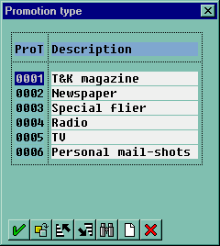 - these definitions need to be changed - Eddie

Step 2 - Define store allocation and validity period
Step 3 - Plan quantity and selling price
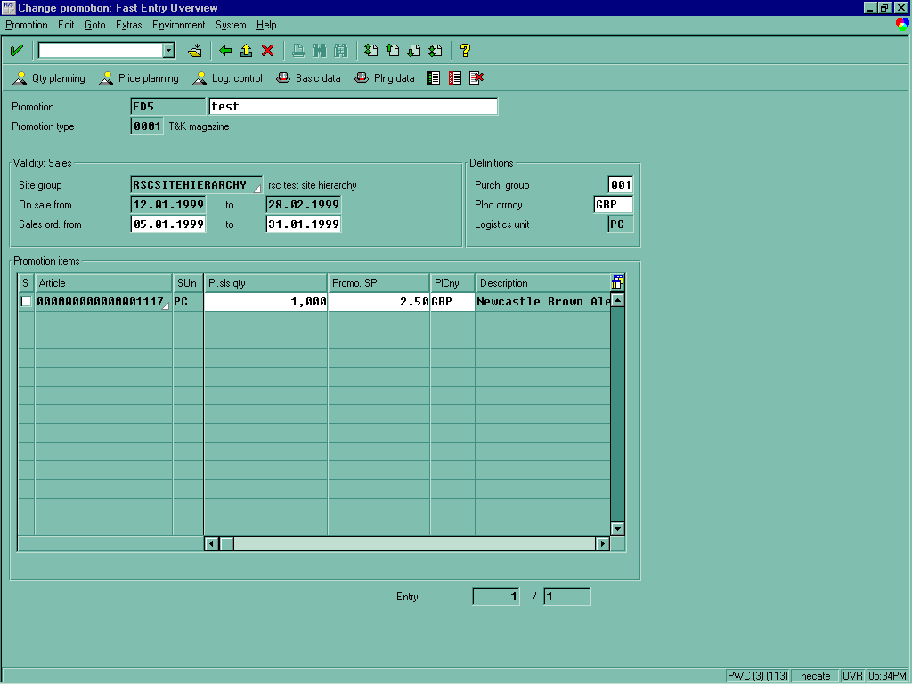
Step 4 - Stock allocation modelling – what methods of allocation are available? For example: preset ratios (by store grade), historical sales, etc
Step 5 - Promotions reporting - what standard facilities are available?

Points to emphasise:
- Category Teams are responsible for co-ordinating promotional activity – collaborating with other categories when appropriate, e.g. World Cup promotions programme had to be co-ordinated across the business.
- Each promotion is planned as a project and has standard process to follow in terms of business case, implementation plan and exit plan
- Supply chain planning also needs to be taken into account – can the DC or RCC support the capacity? Would it be better to deliver direct to store?
- Following initial allocation, the subsequent allocation rules/auto replenishment rules will be defined on a promotion by promotion basis – list options available in SAP
- Promotions always have start and end dates for purchasing and selling stock – promotions will be communicated to the store with initial allocation and merchandising information.

User Exit – EQoS Demonstration
Each promotion will require close collaboration with the supplier to plan/negotiate stock requirements, cost price, other promotional payments, advertising, etc.
We wanted to introduce some new operating principles with our suppliers to ease the workload associated with assessing promotion and sharing information with our suppliers – they can really help us if we let them.
We have been piloting an E-Commerce application called EqoS. This allows us to:
- Formalise the process of agreeing promotion deals with our suppliers
- Exchanging product information?
- Exchanging stock information?

- Case studies of what is achievable – Sainsbury with EQOS, Tesco with GE – Mark Reed
- Types of initiative include:
- Joint category planning – example required
- Forecasting – example required
- Vendor managed inventory – example required
- Joint promotions planning – example required
- New product development – example required

Let me show you a quick example of how this works:

Demonstration: EqoS – Sun Tan Lotion Demo
Content of this demo is still to be confirmed – Mark Reed to assist.

At T&K’s, I would like to think we were established advocates of EDI with our supplier base. However, this type of application allows us greater flexibility:
- Ease of ‘custom workflow’ development
- Provides security to our operational system (SAP)
- Others… (Mark Reed – why should we be showing EqoS ?)

- Mark-down management – how mark-downs are authorised (review process) and communicated to stores. Covered in discussion on seasonal lines.
- Analysis of un-authorised discounts – i.e. those applied at stores (reason code analysis)
- Supply Chain monitoring – see Supply Chain section – analysis of stock cover and availability in store and at the DC. Also covers imports and domestic product tracking.

Managing Seasonal Lines
The final area we focused on as part of our Category Management initiative was the management of seasonal lines. Let me be clear in my definition of seasonal lines.

Nearly all our product lines have some element of seasonality. As with most retailers we have trading peaks at Christmas and Easter, and slower periods during the summer holiday periods. The forecasting capabilities within the SAP system allow us to increase stock levels in store at the appropriate times with limited manual intervention required.
We also list product lines that we assume will only sell during a certain period. Let me give you some examples:
Fashion Lines - ‘high’ fashion lines will only sell for one season
Grocery – Christmas Puddings
Homewares – Garden furniture (do we stock this?)

These are what we call our seasonal lines – and they provide a significant contribution to T&K’s total sales revenue (38% last year).
We faced some specific problems with managing seasonal lines, especially the ‘one-off’ products where there would be limited opportunities for selling the stock once the season was over (particularly in the Fashion Category).
Slide: Managing Seasonal Lines
- Purchasing the correct product quantities – both at line and category level
- Managing sell through
- Mark-down management – ensuring we dispose of stock whilst minimising the reduction in margin – particularly important for the Fashion Category
- Supplier uplift (small % of lines)
- Stock disposal

As part of the Category Management initiative we have introduced two new commercial processes to help us better manage seasonal lines:
- Open to Buy controls
- Mark-down planning

The management of ‘open to buy’ is a fairly well established fashion retailing business control. Introducing the concept to T&K’s was well received, particularly as we have standard facilities within the SAP and Makoro applications to support us.
Demonstration: OTB Controls
As part of the merchandise planning exercise we develop sub-class budget plans that include sales, margin, markdown and closing stock. Using this data we calculate the ‘Open to Buy’ purchase quantity. This provides us with a guide on how much money our category team has available to purchase stock (per week or month) to meet our target performance objectives.
Calculating OTB is a standard function within Makoro.
Many companies use this mechanism to monitor purchase commitments against the OTB budget figure. However, this is often an off line process with two issues:
- Only performed on a monthly basis – commitments have often been made
- Often do not reforecast

At T&K’s we use Makoro as the strategic merchandise planning tool. The budgets are generated away from the operational system. However, once the budgets are set we automatically down load the OTB targets into a dedicated SAP database.
Slide: diagram of SAP/Makoro inferfaces
This OTB database links with SAP purchase order management. All purchase commitments are posted into the OTB database and if the OTB budget is exceeded then SAP can be configured to either reject the PO or raise a warning message to the appropriate inventory analyst. Example can be shown if required.
We re-plan OTB within the overall re-forecasting process. Re-forecasting of merchandise performance budgets is performed on a monthly basis within the Makoro application. Makoro is passed actual performance data on a weekly basis from SAP to provide the basis for the re-forecast. Any changes in OTB are passed down to SAP.
During our first three months of operation we saw some fascinating results coming through. For example: Our inventory analyst on men’s formal trousers spent their entire budget for the season in the first two weeks!
Our challenge for seasonal lines is to ensure we achieve maximum margins and accuratley time the clearing of stock from the business.
We reduce company profitability if:
- We fail to provide enough stock of a good selling line, or
- We are forced to mark-down stock in order to clear it from our stores.
In reality, we have many occurrences of both these scenarios in any week.

Due to the long lead times for manufacturing, it is important that T&K’s control their commitment levels down the supply chain and are able to react quickly to market information. We monitor performance on seasonal lines very closely and develop flexible contracts with our suppliers. We want to be able to increase or decrease capacity at very short notice.

We have also developed mark-down planning rules that are used across our product ranges.
We know, by product class, what the impact of mark-down has on the sales velocity. For example: on ladies XXXXXXX
A 15% price mark-down will double sales velocity
30% price mark-down will increase sales velocity by 3 to 4
50% price mark-down can increase sales velocity by 4+
Price mark-downs are used to ‘enhance’ the desirability of the fashion product – ‘very thing becomes fashionable if the price is right!’

Managing ‘Continuity Product Ranges (grocery and some homewares)

- Automated store stock replenishment on the majority of lines following initial allocations
- Manual re-ordering restricted to those products where it is difficult to keep an accurate inventory record – e.g. reels of rope
- DC/RCC ordering processes (covered in supply chain section)
Space performance management – yield

